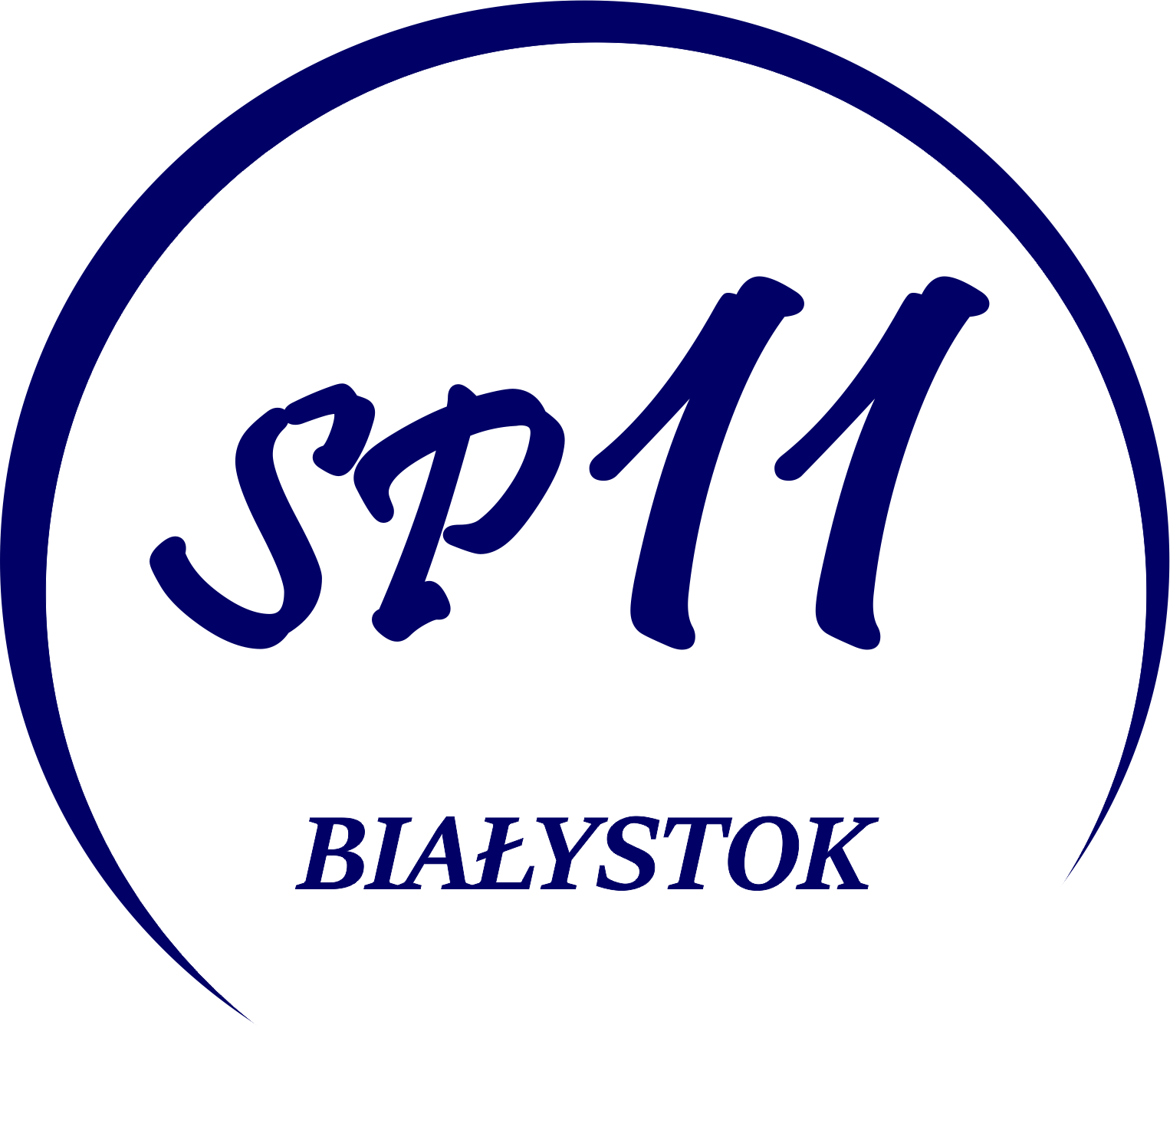

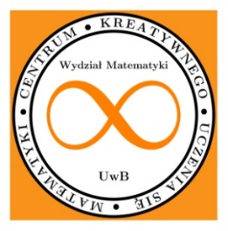
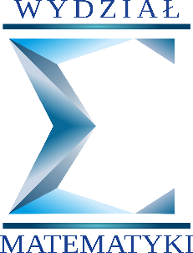

Mathematical Experiment Competition
Rules
1. Organizers of the Competition for a Mathematical Experiment are: Primary School No. 11 in Białystok, Poland, and the Centre for Creative Learning of Mathematics at the Faculty of Mathematics of the University of Bialystok, Poland.
2. Aims of the competition are:
- popularization of mathematics, forming and strengthening an interest in mathematics,
- raising interest of students in the research method and self-discovery of the laws that govern the world,
- showing maths from the creative and searching side, not only awaiting its passive absorption by students,
- shaping analytical thinking through an interdisciplinary approach to teaching science subjects and by deepening mathematical skills in general education.

3. The competition is international. The work can be done in Polish or English language. If the work is done in the native language of the foreign participant, please attach a translation into English. Participants of the competition may be students of primary schools grades VI-VIII, and secondary schools who want to learn mathematics by doing research.
4. The competition task consists in planning and carrying out an experiment leading to conclusions with a mathematical content, as well as documenting this activity in the form of a presentation (containing photos showing the experiment) or a film and sending this documentation to both of the following addresses: konkursmatematycznysp11@gmail.com and eksperyment@math.uwb.edu.pl (because there are two institutions organizing the competition). If the file containing e.g. a movie is large, attach a link to the place where it is placed in the cloud.
5. Each participant may submit one work.
6. By entering the Competition, the Participant declares that he is the sole author of the submitted competition work.
7. The condition for participation in the Competition is granting and not withdrawing, throughout the duration of the Competition, consent to the processing of students' personal data for the purposes of the Competition, including in particular if the student obtains a Laureate or distinction in the Competition for the dissemination of the name and place of residence, in particular on the Organiser's website. However, in the case of all submitted works, the above-mentioned data should be distributed during the exhibition of the works at the organizer's premises.
8. Each of the submitted works should be provided with the name and surname of the Author / Author, information about the school and class attended by the Author, and the title. The work should also include information enabling contact with the Author - e-mail address and / or telephone number. Additionally, each work must be accompanied by a consent to the processing of personal data in the form adopted in the country of origin of the Participant.
9. The works can be sent by April 26, 2026 inclusive to both the following addresses: konkursmatematycznysp11@gmail.com and eksperyment@math.uwb.edu.pl. If the file containing e.g. a movie is large, attach a link to the place where it is placed in the cloud.
10. The texts constituting the content of the work in the presentation or film should be written in the Author's native language. The work should be accompanied by a short summary
(up to one page) in English in a text file.

11. The works will be assessed by a Competition Jury composed of employees of the Centre for Creative Learning of Mathematics and Primary School No. 11 in Bialystok in two age groups:
- pupils of grades VI - VIII of primary schools,
- students of secondary schools.

12. When judging, the Competition Jury will take into account the aesthetics and legibility of the documentation, the originality of the problem studied, and compliance with the principles of conducting scientific experiments.
13. The competition will end with selecting the winners. Attractive prizes await the winners.
14. The list of laureates and awarded works will be published by May 15, 2026 on the website of the Centre for Creative Learning of Mathematics and the website of Primary School No. 11 in Białystok.
15. The organizers of the competition reserve the right to use the submitted works in their publications and publications.
16. By entering the competition, you accept the terms of these regulations.

